EE 141 – Project

Khyle Calpe (405016683)

**Problem 1**

$S=S\left(0\right)-β_{1}\int{SI}-β_{2}\int{SJ}$ $=S\left(0\right)-\frac{1}{s}\left(β_{1}SI+β_{2}SJ\right)E=E\left(0\right)+β_{1}\int{SI}+β_{2}\int{SJ}-γ\int{E}$ $=E\left(0\right)+\frac{1}{s}\left(β_{1}SI+β_{2}SJ-γE\right)I=I\left(0\right)+σ_{1}γ\int{E}-ρ_{1}\int{I}$ $=I\left(0\right)+\frac{1}{s}\left(σ_{1}γE-ρ_{1}I\right)J=J\left(0\right)+σ_{2}γ\int{E}-ρ_{2}\int{J}-q\int{J}$ $=J\left(0\right)+\frac{1}{s}\left(σ_{2}γE-J\left(ρ_{2}+q\right)\right)R=R\left(0\right)+ρ_{1}\int{I}+ρ_{2}\int{J}$ $=R\left(0\right)+ρ_{1}I+ρ_{2}JD=D\left(0\right)+q\int{J}$ $=D\left(0\right)+\frac{qJ}{s}$

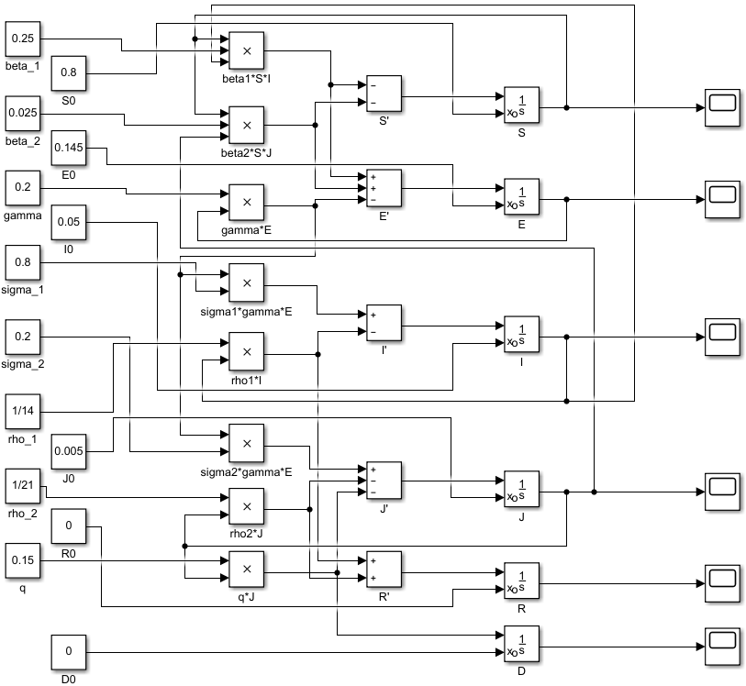

Fig 1.1: Simulink diagram of the non-linearized population model.

Suggested Initial Condition:

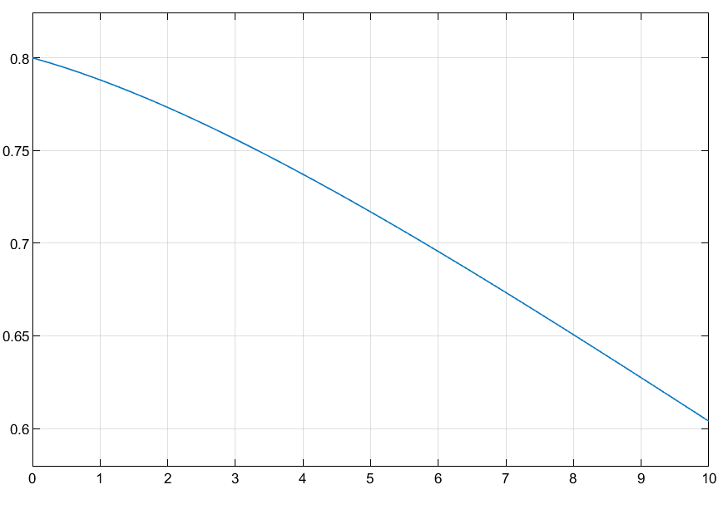 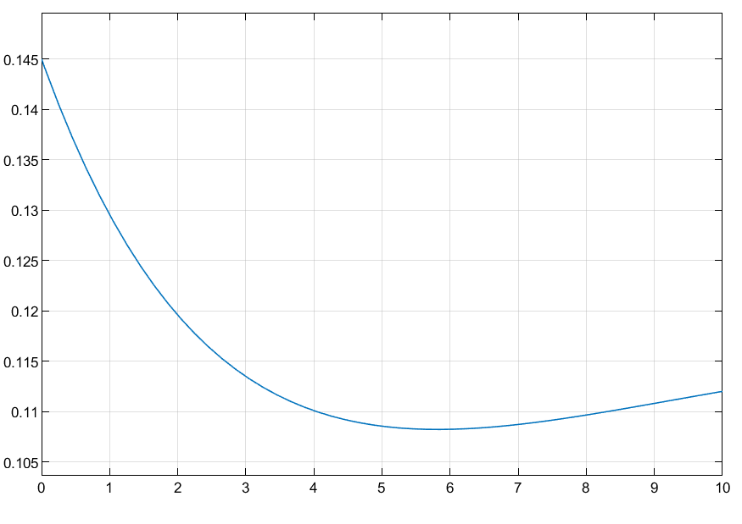 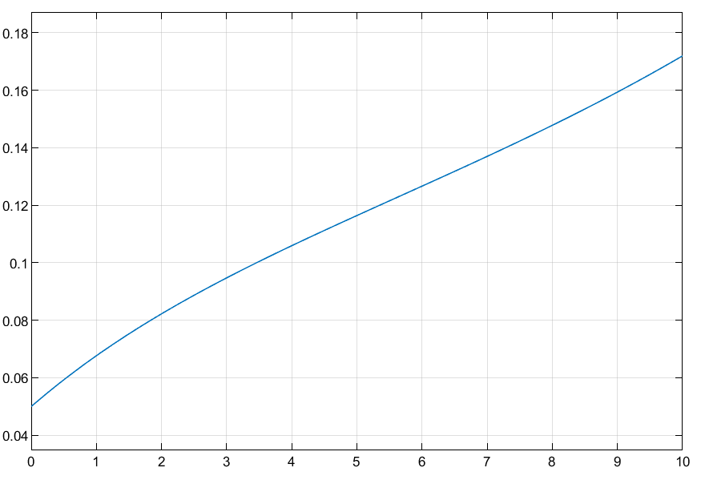

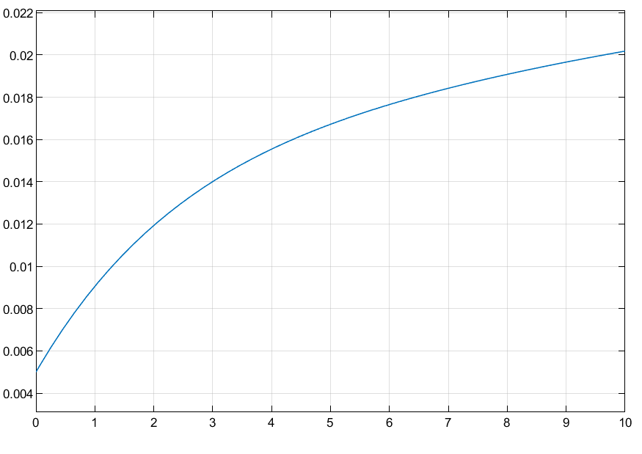 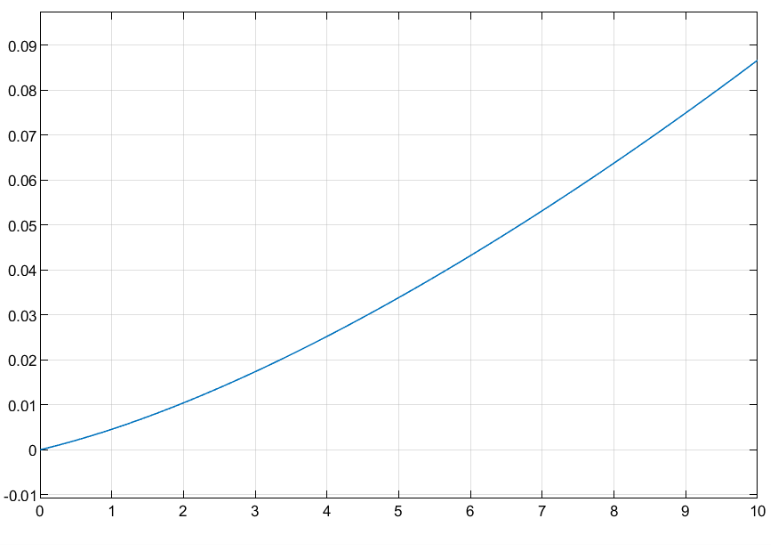 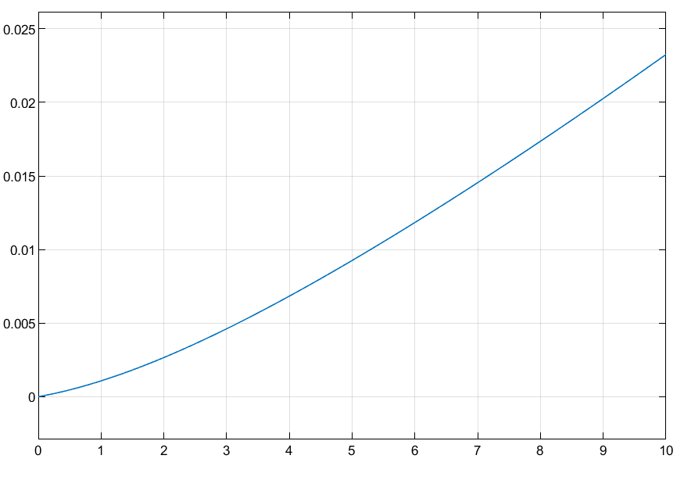

Figure 1.2: From top left to bottom right, these are the scope response plots for S, E, I, J, R, D using the suggested initial conditions. Altering the initial conditions produces the same responses.

Based on the results, as time grows, the amount of susceptible individuals falls to about 0.6 of the population, indicating the steady transition from class S to class E. The amount of exposed fall rapidly from 0.145 to less than 0.11 of the population, which indicates that exposed individuals rapidly become infected during the beginning of the model period and then slowly recover over time. The amount of infected individuals with mild or no symptoms at all grows linearly over time. Similarly, the amount of infected individuals that are seriously ill grows linearly over time except during the beginning of the model period, in which the amount rises rapidly. Although both populations in classes I and J behave similarly, it is worth noting that the population in class I grows from 0.05 to 0.08 while the population in class J grows from 0.005 to 0.009. The model predicts that people will fall seriously ill to the virus faster than contracting the virus with mild to no symptoms. The amount of recovered individuals and individuals that have died grow similarly. However, based on the plots, less than 9% of the population will recover while only less than 2.5% will die. Although these values change based on the initial conditions, the relations and trends between classes remain the same for all initial conditions.

**Problem 2**

The amount of hospital beds necessary for treating the population in class J varies based on the initial population and the trend of growth of the population. Initially, the amount of hospital beds necessary is the value of the initial population in class J. Then, the amount rises rapidly as indicated by the growth from $T=0$ to $T=2$ in the response plot. Afterward, the amount still rises, but the demand for the beds significantly stabilizes and wanes over time.

**Problem 3**

Equilibrium points:

$$\left[\begin{matrix}\begin{matrix}-β_{1}SI-β_{2}SJ \\ β_{1}SI+β_{2}SJ-\left(1-u\right)γE \\ \left(1-u\right)σ_{1}γE-ρ_{1}I\end{matrix} \\ \begin{matrix}\left(1-u\right)σ_{1}γE-ρ_{1}J-qJ \\ ρ_{1}I+ρ_{2}J \\ qJ\end{matrix}\end{matrix}\right]=\left[\begin{matrix}\begin{matrix}0 \\ 0 \\ 0\end{matrix} \\ \begin{matrix}0 \\ 0 \\ 0\end{matrix}\end{matrix}\right]→\left[\begin{matrix}\begin{matrix}β_{1}SI \\ β_{1}SI+β_{2}SJ \\ \left(1-u\right)σ_{1}γE\end{matrix} \\ \begin{matrix}\left(1-u\right)σ_{1}γE \\ ρ_{1}I \\ qJ\end{matrix}\end{matrix}\right]=\left[\begin{matrix}\begin{matrix}{-β}_{2}SJ \\ \left(1-u\right)γE \\ ρ_{1}I\end{matrix} \\ \begin{matrix}ρ_{1}J+qJ \\ -ρ_{2}J \\ 0\end{matrix}\end{matrix}\right]→\left[\begin{matrix}\begin{matrix}β_{1}SI \\ 0 \\ \left(1-u\right)σ_{1}γE\end{matrix} \\ \begin{matrix}\left(1-u\right)σ_{1}γE \\ ρ_{1}I \\ J\end{matrix}\end{matrix}\right]=\left[\begin{matrix}\begin{matrix}{-β}_{2}SJ \\ \left(1-u\right)γE \\ ρ_{1}I\end{matrix} \\ \begin{matrix}0 \\ 0 \\ 0\end{matrix}\end{matrix}\right]$$

$$\left[\begin{matrix}\begin{matrix}β_{1}SI \\ 0 \\ \left(1-u\right)σ_{1}γE\end{matrix} \\ \begin{matrix}σ_{1}γE \\ I \\ J\end{matrix}\end{matrix}\right]=\left[\begin{matrix}\begin{matrix}{-β}_{2}SJ \\ \left(1-u\right)γE \\ 0\end{matrix} \\ \begin{matrix}{uσ}_{1}γE \\ 0 \\ 0\end{matrix}\end{matrix}\right]→\left[\begin{matrix}\begin{matrix}0 \\ 0 \\ 1\end{matrix} \\ \begin{matrix}1 \\ I \\ J\end{matrix}\end{matrix}\right]=\left[\begin{matrix}\begin{matrix}0 \\ 0 \\ u\end{matrix} \\ \begin{matrix}u \\ 0 \\ 0\end{matrix}\end{matrix}\right]$$

Linearization model:

Let $\left\{S, E, I, J, R, D\right\}=x_{i},0≤i≤5$.

$$A=\frac{∂f}{∂x}{\left.​\right|}_{\left\{S, E, I, J, R, D\right\}=0,u=1}=\left[\begin{matrix}\begin{matrix}\begin{matrix}\begin{matrix}-β_{1}I-β_{2}J \\ β_{1}I+β_{2}J\end{matrix} \\ 0\end{matrix} \\ \begin{matrix}0 \\ \begin{matrix}0 \\ 0\end{matrix}\end{matrix}\end{matrix} & \begin{matrix}\begin{matrix}\begin{matrix}\begin{matrix}0 \\ -\left(1-u\right)γ\end{matrix} \\ \left(1-u\right)σ_{1}γ\end{matrix} \\ \begin{matrix}\left(1-u\right)σ_{1}γ \\ \begin{matrix}0 \\ 0\end{matrix}\end{matrix}\end{matrix} & \begin{matrix}\begin{matrix}\begin{matrix}\begin{matrix}-β_{1}S \\ β_{1}S\end{matrix} \\ -ρ_{1}\end{matrix} \\ \begin{matrix}0 \\ \begin{matrix}ρ_{1} \\ 0\end{matrix}\end{matrix}\end{matrix} & \begin{matrix}\begin{matrix}\begin{matrix}\begin{matrix}-β_{2}S \\ β_{2}S\end{matrix} \\ 0\end{matrix} \\ \begin{matrix}-ρ_{1}-q \\ \begin{matrix}ρ_{2} \\ q\end{matrix}\end{matrix}\end{matrix} & \begin{matrix}\begin{matrix}\begin{matrix}\begin{matrix}0 \\ 0\end{matrix} \\ 0\end{matrix} \\ \begin{matrix}0 \\ \begin{matrix}0 \\ 0\end{matrix}\end{matrix}\end{matrix} & \begin{matrix}\begin{matrix}\begin{matrix}0 \\ 0\end{matrix} \\ 0\end{matrix} \\ \begin{matrix}0 \\ \begin{matrix}0 \\ 0\end{matrix}\end{matrix}\end{matrix}\end{matrix}\end{matrix}\end{matrix}\end{matrix}\end{matrix}\right] \\ =\left[\begin{matrix}\begin{matrix}\begin{matrix}\begin{matrix}0 \\ 0\end{matrix} \\ 0\end{matrix} \\ \begin{matrix}0 \\ \begin{matrix}0 \\ 0\end{matrix}\end{matrix}\end{matrix} & \begin{matrix}\begin{matrix}\begin{matrix}\begin{matrix}0 \\ -\left(1-u\right)γ\end{matrix} \\ \left(1-u\right)σ_{1}γ\end{matrix} \\ \begin{matrix}\left(1-u\right)σ_{1}γ \\ \begin{matrix}0 \\ 0\end{matrix}\end{matrix}\end{matrix} & \begin{matrix}\begin{matrix}\begin{matrix}\begin{matrix}0 \\ 0\end{matrix} \\ -ρ_{1}\end{matrix} \\ \begin{matrix}0 \\ \begin{matrix}ρ_{1} \\ 0\end{matrix}\end{matrix}\end{matrix} & \begin{matrix}\begin{matrix}\begin{matrix}\begin{matrix}0 \\ 0\end{matrix} \\ 0\end{matrix} \\ \begin{matrix}-ρ_{1}-q \\ \begin{matrix}ρ_{2} \\ q\end{matrix}\end{matrix}\end{matrix} & \begin{matrix}\begin{matrix}\begin{matrix}\begin{matrix}0 \\ 0\end{matrix} \\ 0\end{matrix} \\ \begin{matrix}0 \\ \begin{matrix}0 \\ 0\end{matrix}\end{matrix}\end{matrix} & \begin{matrix}\begin{matrix}\begin{matrix}0 \\ 0\end{matrix} \\ 0\end{matrix} \\ \begin{matrix}0 \\ \begin{matrix}0 \\ 0\end{matrix}\end{matrix}\end{matrix}\end{matrix}\end{matrix}\end{matrix}\end{matrix}\end{matrix}\right] \\ B=\frac{∂f}{∂u}{\left.​\right|}_{\left\{S, E, I, J, R, D\right\}=0,u=1}=\left[\begin{matrix}\begin{matrix}0 \\ 0 \\ -σ_{1}γE\end{matrix} \\ \begin{matrix}-σ_{1}γE \\ 0 \\ 0\end{matrix}\end{matrix}\right]=\left[\begin{matrix}\begin{matrix}0 \\ 0 \\ 0\end{matrix} \\ \begin{matrix}0 \\ 0 \\ 0\end{matrix}\end{matrix}\right]$$

$$\frac{d}{dt}δx=\left[\begin{matrix}\begin{matrix}0 \\ -\left(1-u\right)γδx_{1} \\ \left(1-u\right)γδx_{1}-ρ_{1}δx_{2}\end{matrix} \\ \begin{matrix}\left(1-u\right)γδx_{1}-\left(ρ_{1}+q\right)δx_{3} \\ ρ_{1}δx_{2}+ρ_{2}δx_{3} \\ qδx_{3}\end{matrix}\end{matrix}\right]=\left[\begin{matrix}\begin{matrix}0 \\ -\left(1-u\right)γδE \\ \left(1-u\right)γδE-ρ_{1}δI\end{matrix} \\ \begin{matrix}\left(1-u\right)γδE-\left(ρ_{1}+q\right)δJ \\ ρ_{1}δE+ρ_{2}δJ \\ qδJ\end{matrix}\end{matrix}\right]$$

Based on the linearized model, the computed equilibrium pair contains $u=1$, which is impossible to implement. Additionally, the linearized model doesn’t contain $δu$ and other classes, which further supports the conclusion that the equilibrium pair cannot be used in the model.

**Problem 4**

$$x=x_{e}+δx=\left[\begin{matrix}\begin{matrix}0 \\ -\left(1-u\right)γδE \\ \left(1-u\right)γδE-ρ_{1}δI\end{matrix} \\ \begin{matrix}\left(1-u\right)γδE-\left(ρ_{1}+q\right)δJ \\ ρ_{1}δE+ρ_{2}δJ \\ qδJ\end{matrix}\end{matrix}\right]→\left[\begin{matrix}\begin{matrix}S^{'} \\ E^{'} \\ I^{'}\end{matrix} \\ \begin{matrix}J^{'} \\ R^{'} \\ D^{'}\end{matrix}\end{matrix}\right]=\left[\begin{matrix}\begin{matrix}0 \\ -\left(1-u\right)γδE \\ \left(1-u\right)γδE-ρ_{1}δI\end{matrix} \\ \begin{matrix}\left(1-u\right)γδE-\left(ρ_{1}+q\right)δJ \\ ρ_{1}δE+ρ_{2}δJ \\ qδJ\end{matrix}\end{matrix}\right] \\ \left[\begin{matrix}\begin{matrix}S \\ E \\ I\end{matrix} \\ \begin{matrix}J \\ R \\ D\end{matrix}\end{matrix}\right]=\left[\begin{matrix}\begin{matrix}S\left(0\right) \\ E(0)-\frac{1}{s}\left(\left(1-u\right)γδE\right) \\ I\left(0\right)+\frac{1}{s}\left(\left(1-u\right)γδE-ρ_{1}δI\right)\end{matrix} \\ \begin{matrix}J\left(0\right)+\frac{1}{s}\left(\left(1-u\right)γδE-\left(ρ_{1}+q\right)δJ\right) \\ R\left(0\right)+\frac{1}{s}\left(ρ_{1}δE+ρ_{2}δJ\right) \\ D\left(0\right)+\frac{1}{s}qδJ\end{matrix}\end{matrix}\right]$$

$$E=E\left(0\right)-\frac{1}{s}\left(\left(1-u\right)γE\right) \\ E\left(1+\frac{1}{s}\left(1-u\right)γ\right)=E\left(0\right) \\ E\left(\frac{s+\left(1-u\right)γ}{s}\right)=E\left(0\right) \\ E=\frac{sE\left(0\right)}{s+\left(1-u\right)γ}$$

$$J=J\left(0\right)+\frac{1}{s}\left(\left(1-u\right)γE-\left(ρ_{1}+q\right)J\right) \\ J\left(1+\frac{1}{s}\left(ρ_{1}+q\right)\right)=J\left(0\right)+\frac{1}{s}\left(\left(1-u\right)γ\frac{sE\left(0\right)}{s+\left(1-u\right)γ}\right) \\ J\left(\frac{s+ρ_{1}+q}{s}\right)=J\left(0\right)+\frac{\left(1-u\right)γE\left(0\right)}{s+\left(1-u\right)γ} \\ J\left(\frac{s+ρ_{1}+q}{s}\right)=\frac{J\left(0\right)\left(s+\left(1-u\right)\right)+γ\left(1-u\right)γE\left(0\right)}{s+\left(1-u\right)γ}{\left.​\right|}_{E\left(0\right)=0}$$

$$\frac{J}{J\left(0\right)}=\frac{s\left(s+\left(1-u\right)\right)}{(s+\left(1-u\right)γ)(s+(ρ_{1}+q))}$$

The transfer function $|J\left(s\right)|$ has a pole on $s=γ(u-1)$. Hence, one of the poles is directly proportional to the input $u$.

**Problem 5**

$$δS=S\left(0\right) \\ δE=E\left(0\right)-\frac{1}{s}\left(\left(1-u\right)γδE\right) \\ δI=I\left(0\right)+\frac{1}{s}\left(\left(1-u\right)γδE-ρ_{1}δI\right) \\ δJ=J\left(0\right)+\frac{1}{s}\left(\left(1-u\right)γδE-\left(ρ_{1}+q\right)δJ\right) \\ δR=R\left(0\right)+\frac{1}{s}\left(ρ_{1}δE+ρ_{2}δJ\right) \\ δD=D\left(0\right)+\frac{1}{s}qδJ$$

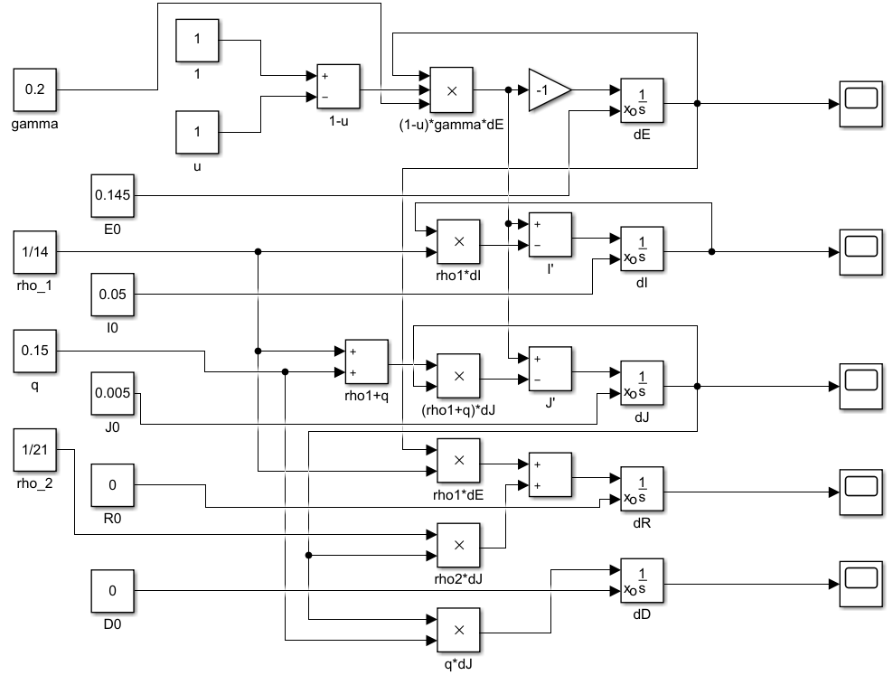

Fig 5.1: Simulink diagram of the linearized population model.

$u=0.05$:

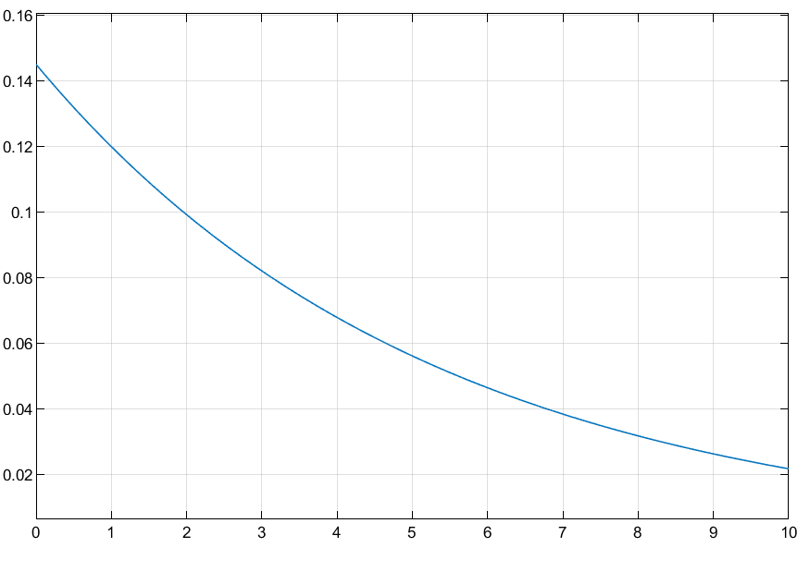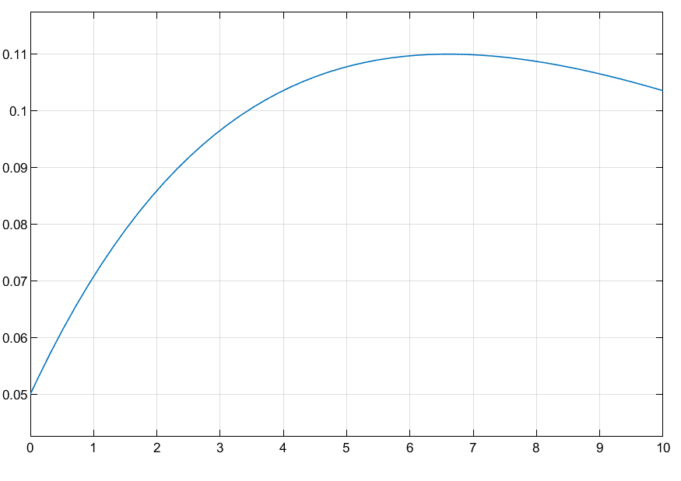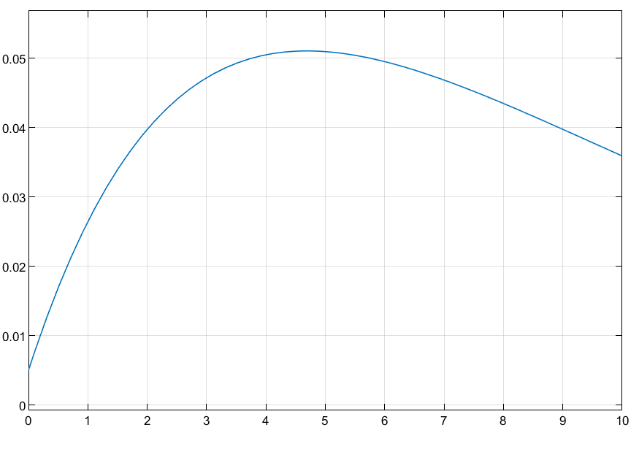

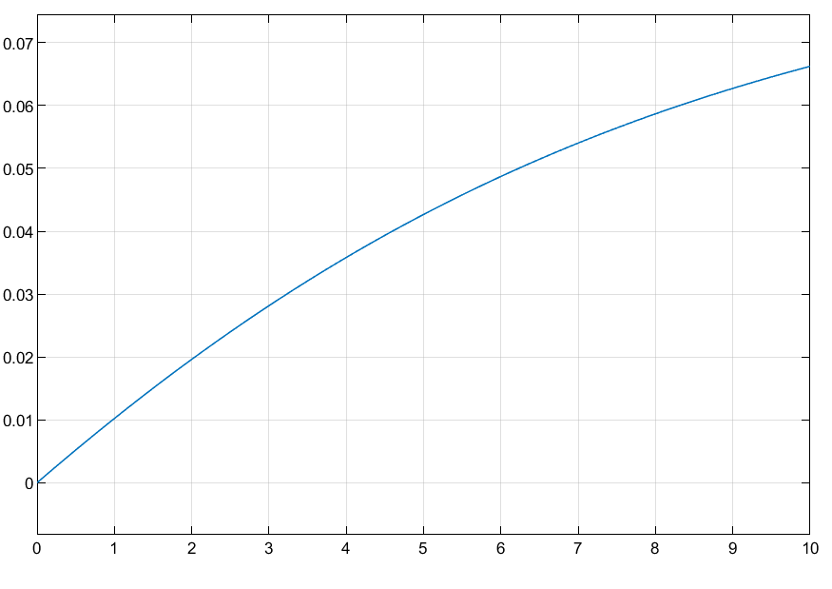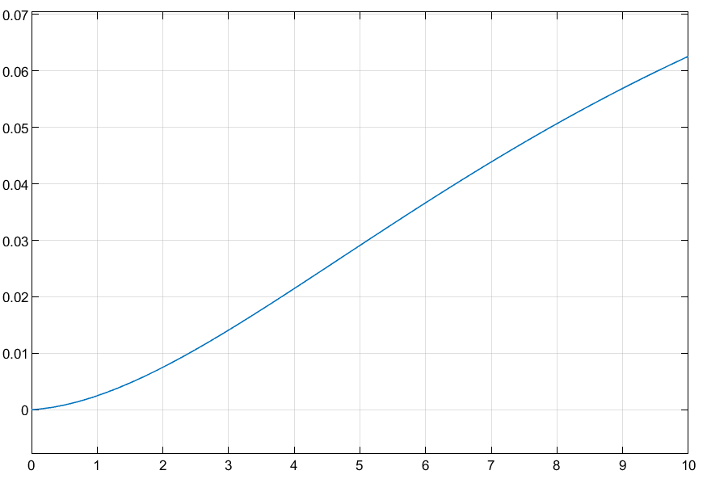

Figure 5.2: From top left to bottom right, these are the scope response plots for E, I, J, R, D.

$u=0.50$:

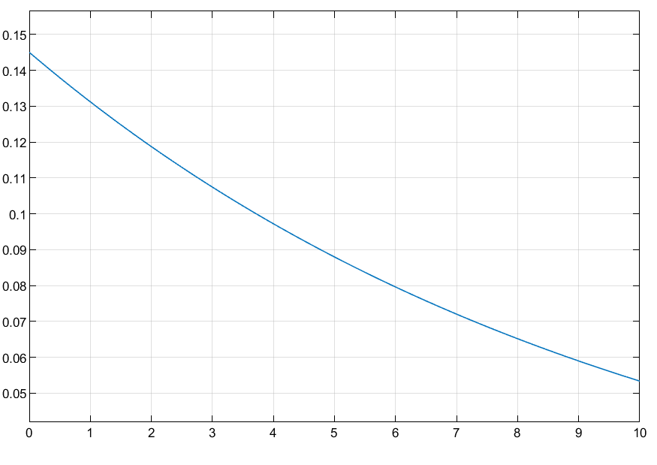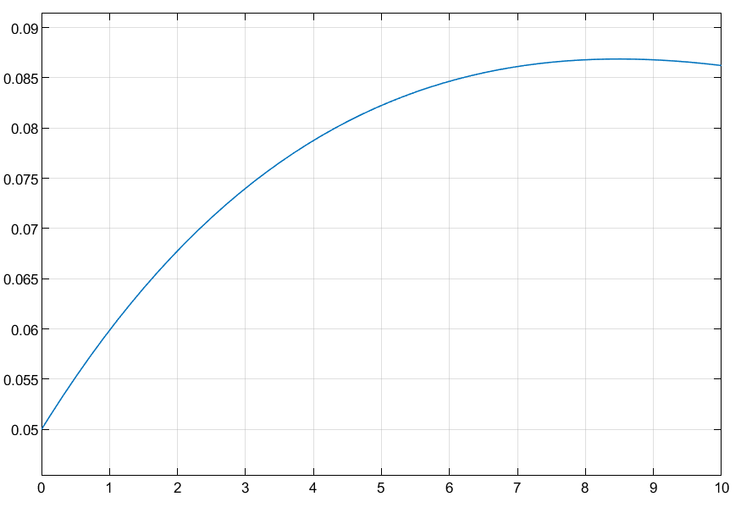 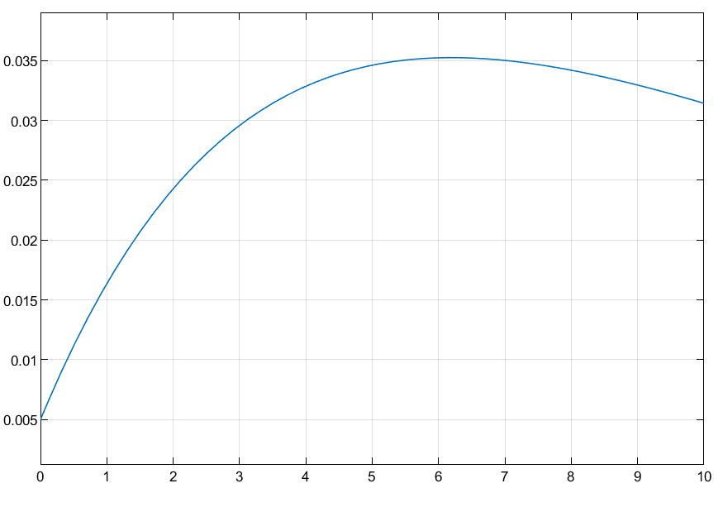

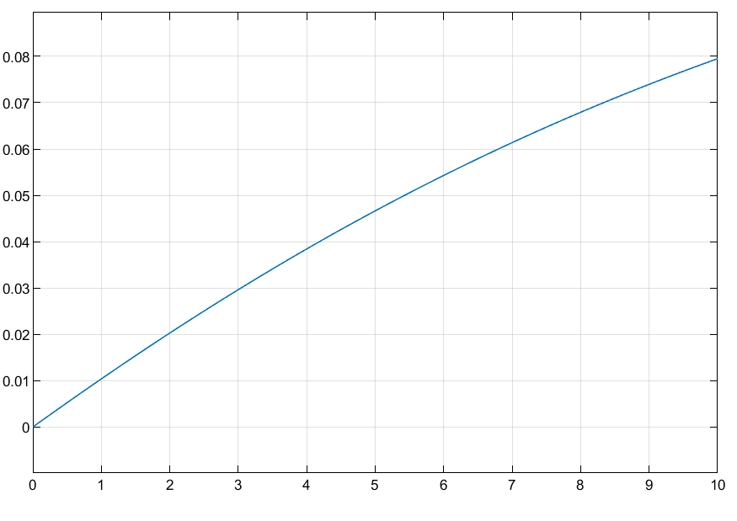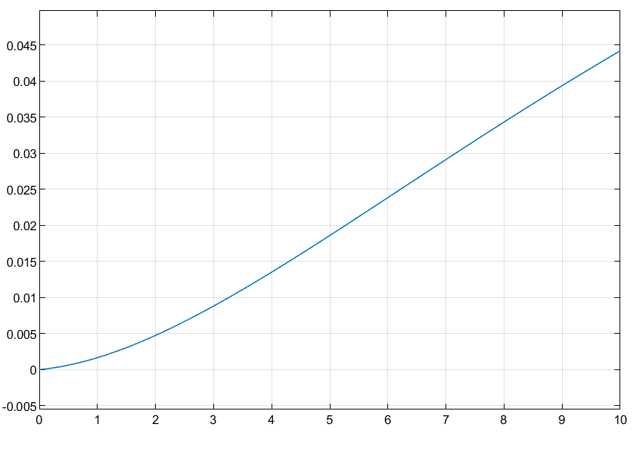

Figure 5.3: From top left to bottom right, these are the scope response plots for E, I, J, R, D.

$u=0.99$:

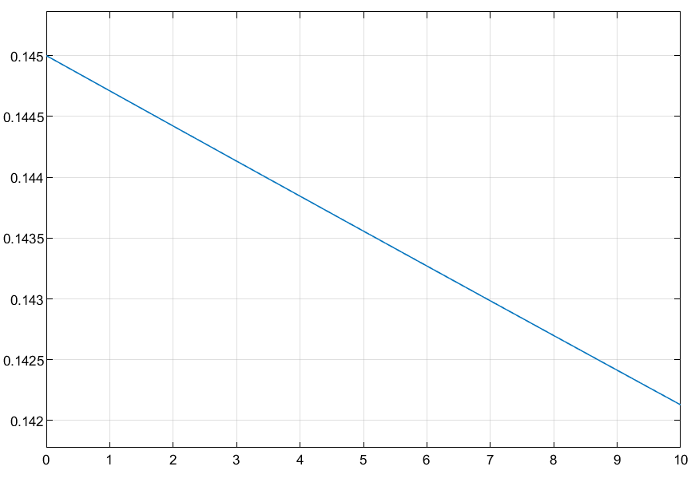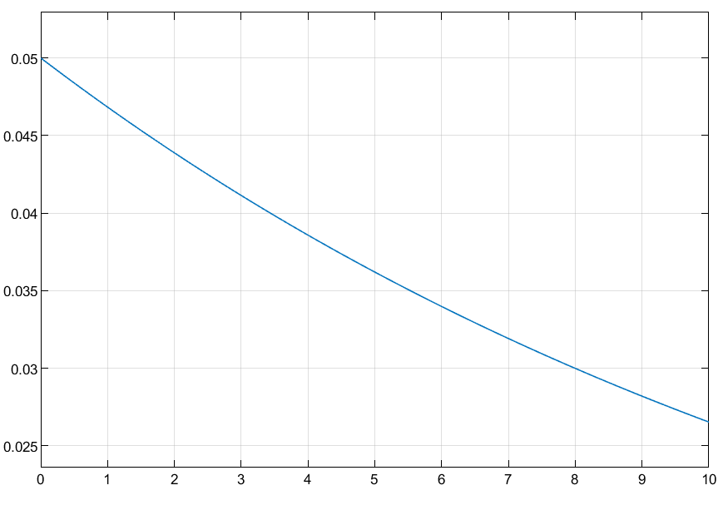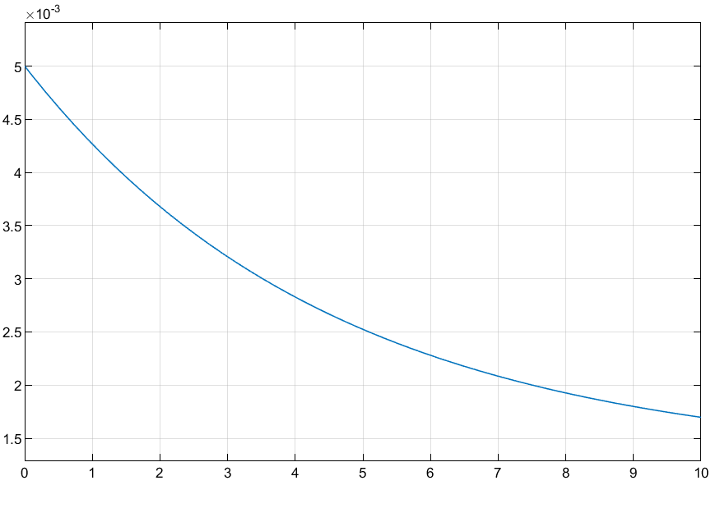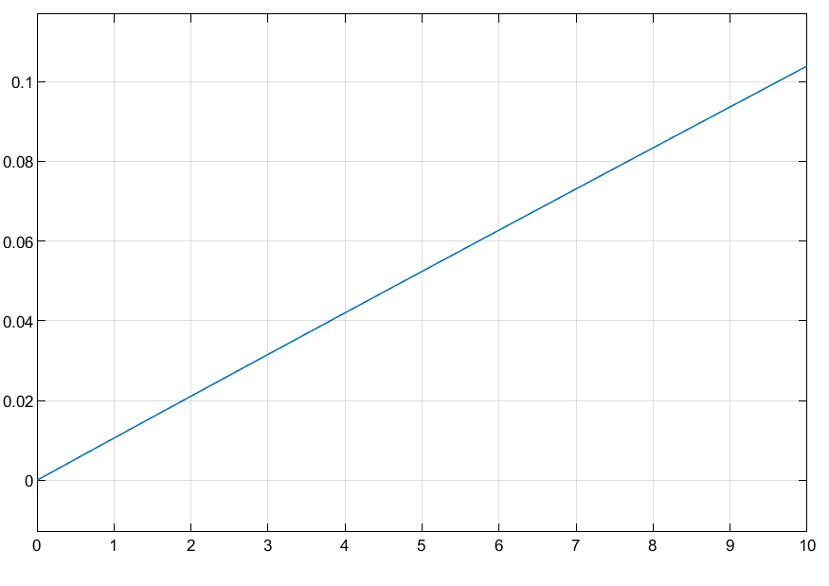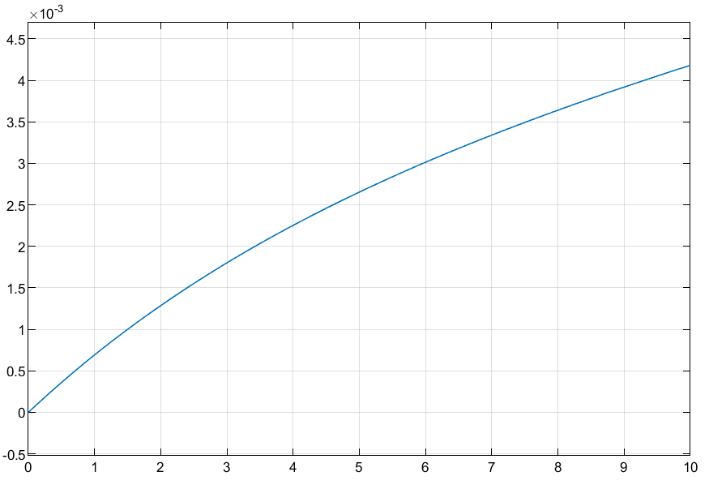

Figure 5.4: From top left to bottom right, these are the scope response plots for E, I, J, R, D.

Compared to the non-linearized model, the linearized model shows that the use of face masks, regardless of the population size, reduces exposure, mild and serious infections, and death. Comparing the class E scope responses, the population of exposed individuals decreases significantly slower than the original model, which means people are contracting the virus slower. Comparing the class I scope responses at the end of the model period, the population of infected individuals with mild or no symptoms drops from 17% to a range between ~10.5% to 2.5% based on face mask usage. Comparing the class J scope responses at the end of the model period, the population that are seriously ill varies from 2% to 3.5% to 1.5% based on mask usage. Comparing the class R scope responses at the end of the model period, the population of recovered individuals varies from 8.5% to a range between 6.5% to 10.5% based on mask usage. Comparing the class D scope responses at the end of the model period, the population that have died drops from 2.25% to a range between 6.5% to 0.4% based on mask usage. The variation in the scope responses between the original model and the linearized model is the variation in the population exposed to the virus or class E. The introduction of the face masks as the input $u$ varies the population in class E between 0 and 1. As a result, the populations in class E change slower in time. The change then stabilizes the response of the other classes.

**Problem 6**

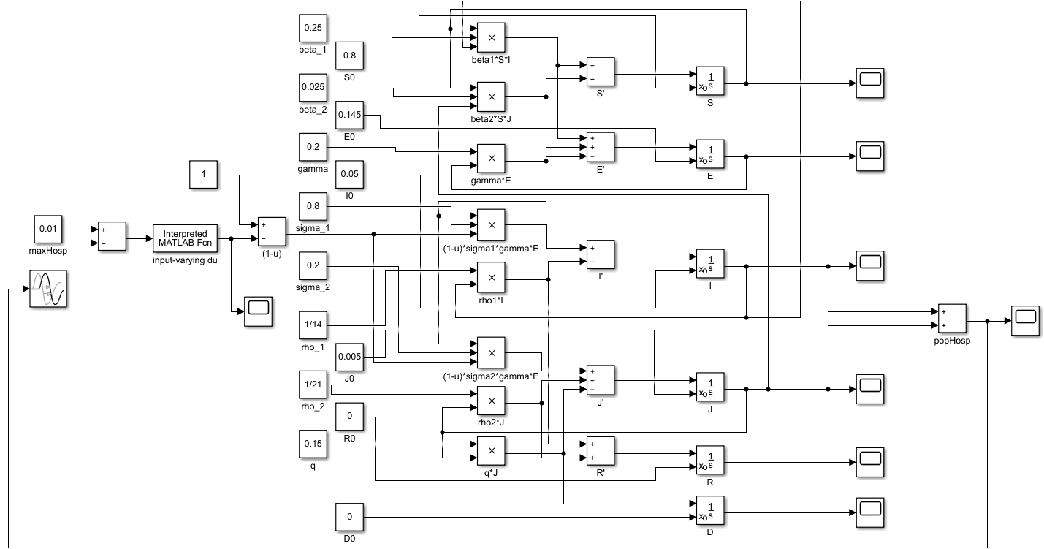

Figure 6.1: Simulink diagram of the closed-loop system used to implement the mask policy $u$.

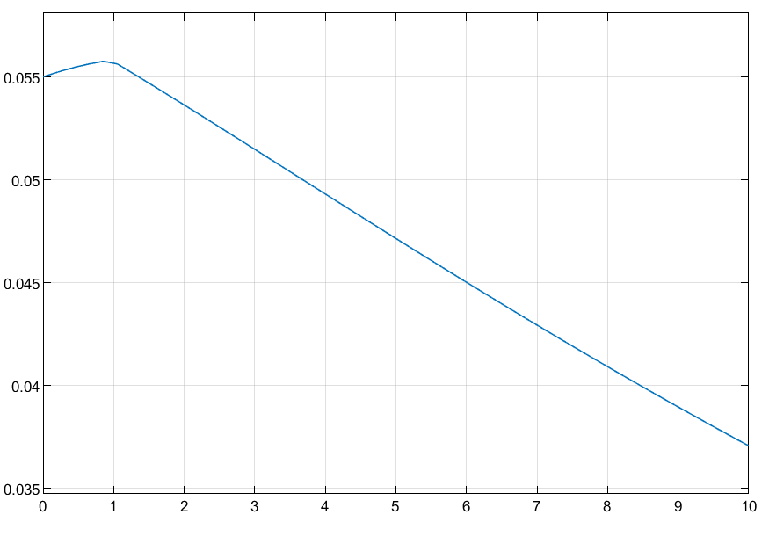

Figure 6.2: Sum of class I and J, which indicates that the policy reduced hospitalized patients to a range between 3.5 to 4% of the total population.

Based on simulation, the policy reduced the population of class R to under 3.5% and the class D population to 0.5%. Hence, the policy caused recovery to double in comparison to the original model. Unfortunately, the implementation fails to keep the hospitalized population under 1%.

**Problem 7**

Depending on initial conditions, the number of people hospitalized can vary significantly. However, the downward trend remains the same. The same trend applies for all classes. In a general case of initial conditions, I would implement the controller in such a way to drastically increase the introduction of face masks into the system if initial conditions are dire. Conversely, the opposite applies during sufficiently noncritical initial conditions.